**Lab No.3**

01.Write a program that asks the user to enter two numbers, obtains them from the user and prints their sum, product, difference, quotient and remainder.

#include <stdio.h>

#include <stdlib.h>

int main (){

int num1, num2;

printf("Enter The First Number: ");

scanf("%d", &num1);

printf("Enter The Second Number: "); **Out Put:**

scanf("%d", &num2);

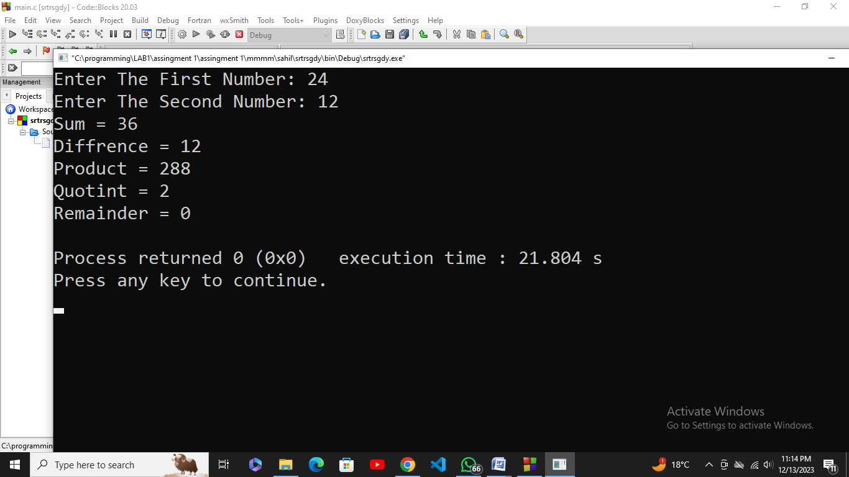

int sum = num1 + num2;

int prod = num1 * num2;

int diffr = num1 - num2;

int quot = num1 / num2;

int rem = num1 % num2;

printf("Sum = %d\n", sum);

printf("Diffrence = %d\n", diffr);

printf("Product = %d\n", prod);

printf("Quotint = %d\n", quot);

printf("Remainder = %d\n", rem);

return 0;

}

02. State the order of evaluation of the operators in each of the following C statements and show the value of x after each statement is performed.

1. x = 7 + 3 * 6 / 2 - 1;
2. x = 2 % 2 + 2 * 2 - 2 / 2;
3. x = ( 3 * 9 * ( 3 + ( 9 * 3 / ( 3 ) ) ) );

#include <stdio.h>

int main() {

int x;

x = 7 + 3 * 6 / 2 - 1;

printf("In First statement the Value of x = %d\n", x);

x = 2 % 2 + 2 * 2 - 2 / 2;

printf("In Second statement the Value of x = %d\n", x);

x = (3 * 9 * (3 + (9 * 3 / (3))));

printf("In Third statement the Value of x = %d\n", x);

return 0;

}

**Out put:**

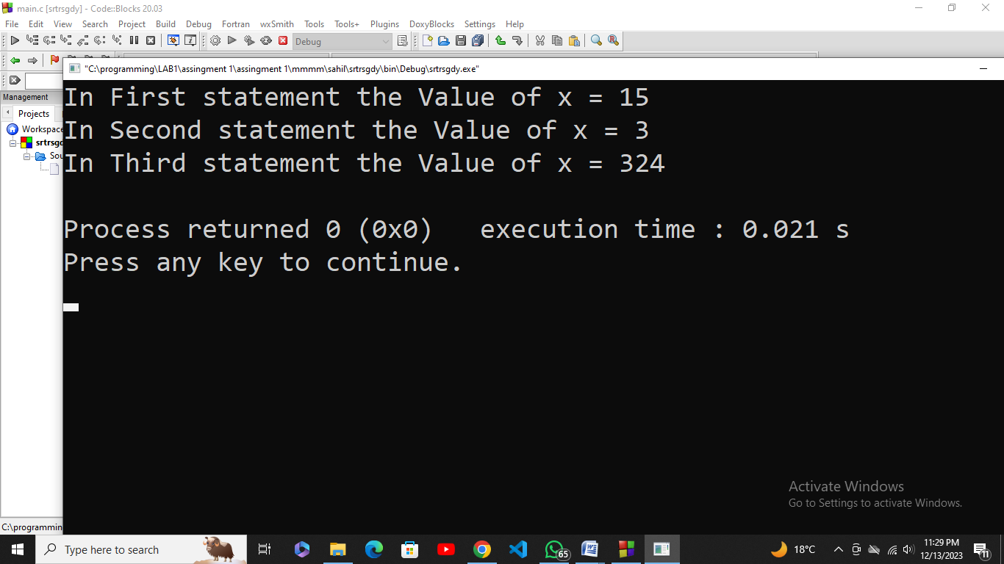

03. Write c program that find the result of the following operations: you are allowed to initialize any values. Observe and write in comment how that operation produce results.

1. 5 + 4
2. 10/2
3. True OR False
4. 20 MOD 3
5. 5< 8
6. 25 MOD 70
7. “A” > “H”
8. NOT True
9. 25/70
10. False AND True
11. 20 * 0.5
12. 35 <= 35

#include <stdio.h>

#include <stdlib.h>

int main() { **Out put:**

int a,b,c, d,e, f, g,h,i,j,l;

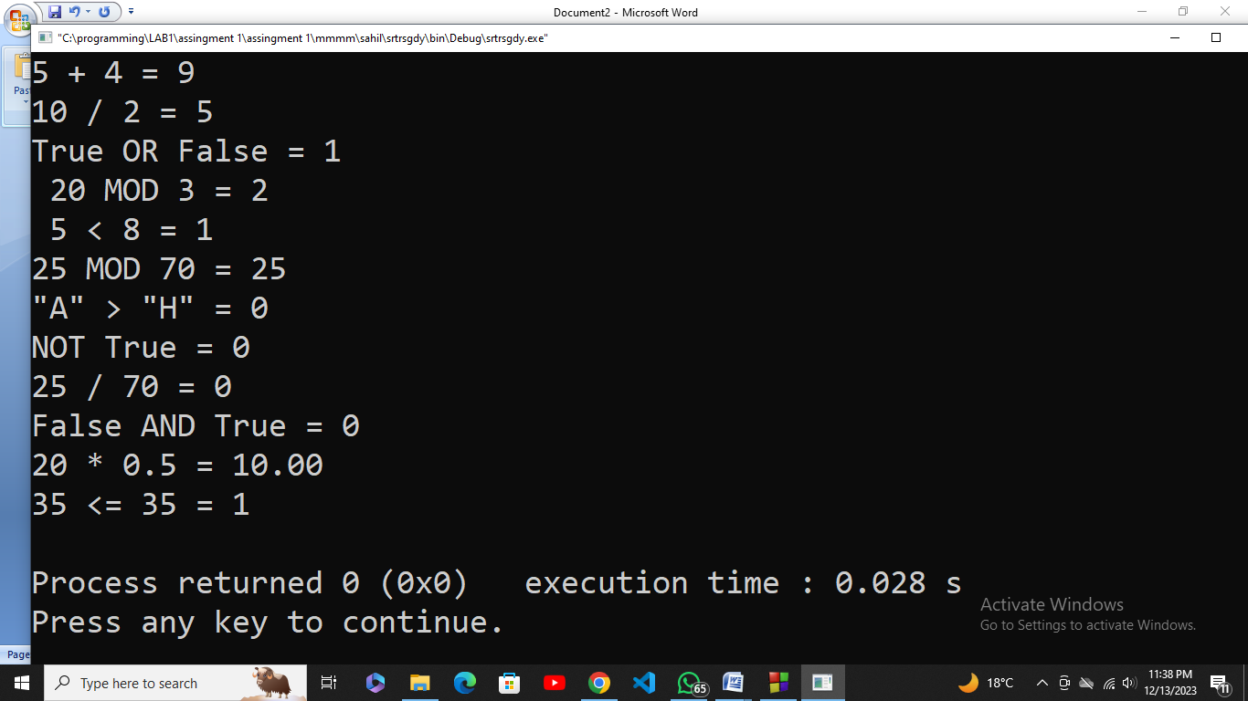 float k;

a = 5 + 4;

printf("5 + 4 = %d\n", a);

b = 10 / 2;

printf("10 / 2 = %d\n",b);

int True = 1, False = 0;

c = True || False;

printf("True OR False = %d\n", c);

d = 20 % 3;

printf(" 20 MOD 3 = %d\n", d);

e = 5 < 8;

printf(" 5 < 8 = %d\n",e);

f = 25 % 70;

printf("25 MOD 70 = %d\n", f);

g = 'A' > 'H';

printf("\"A\" > \"H\" = %d\n", g);

h = !True;

printf("NOT True = %d\n", h);

i = 25 / 70;

printf("25 / 70 = %d\n",i);

j = False && True;

printf("False AND True = %d\n",j);

k = 20 * 0.5;

printf("20 * 0.5 = %.2f\n",k);

l = 35 <= 35;

printf("35 <= 35 = %d\n", l);

return 0;}

04. Write C program to create a BMI calculator application that reads the user’s weight in pounds and height in inches (or, if you prefer, the user’s weight in kilograms and height in meters), then calculates and displays the user’s body mass index. **Hint:** BMI = kg/m2

#include <stdio.h>

#include <stdlib.h>

int main() {

float a, b, bmi;

printf("Enter The Weight Of Body In Pound: ");

scanf("%f", &a);

printf("Enter The Height Of Body In Inches: "); **Out put:**

scanf("%f", &b);

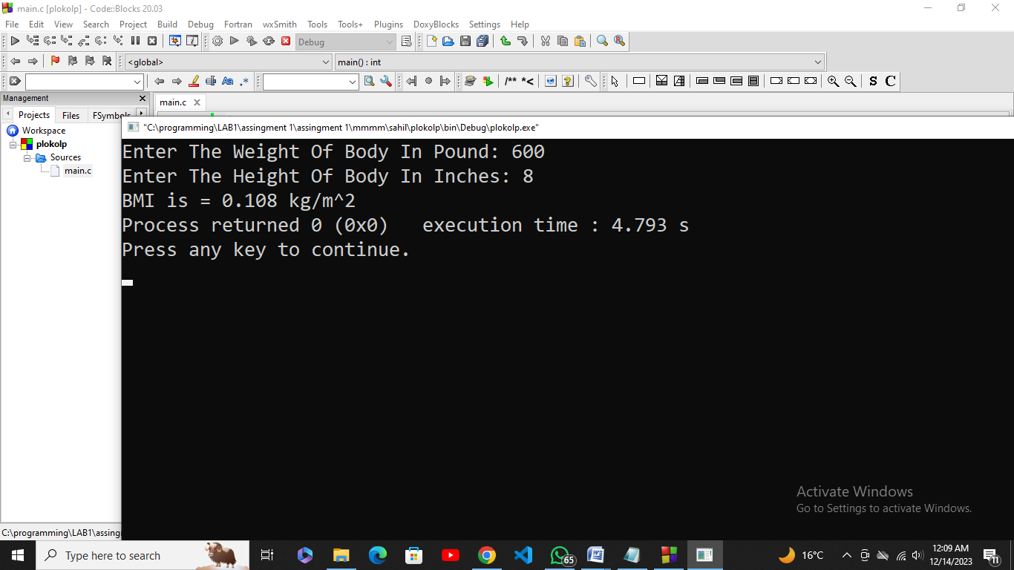

a = a*0.45359237;

a = a*0.0254;

bmi = a / (b*b);

printf("BMI is = %.3f kg/m^2",bmi);

return 0;

}

05. Write a program for swapping two numbers without using a third variable. Ask user to enter the two numbers.

#include <stdio.h>

int main(){

int a,b;

printf("Enter First Number: ");

scanf("%d",&a);

printf("Enter Second Number: "); **Out put:**

scanf("%d",&b);

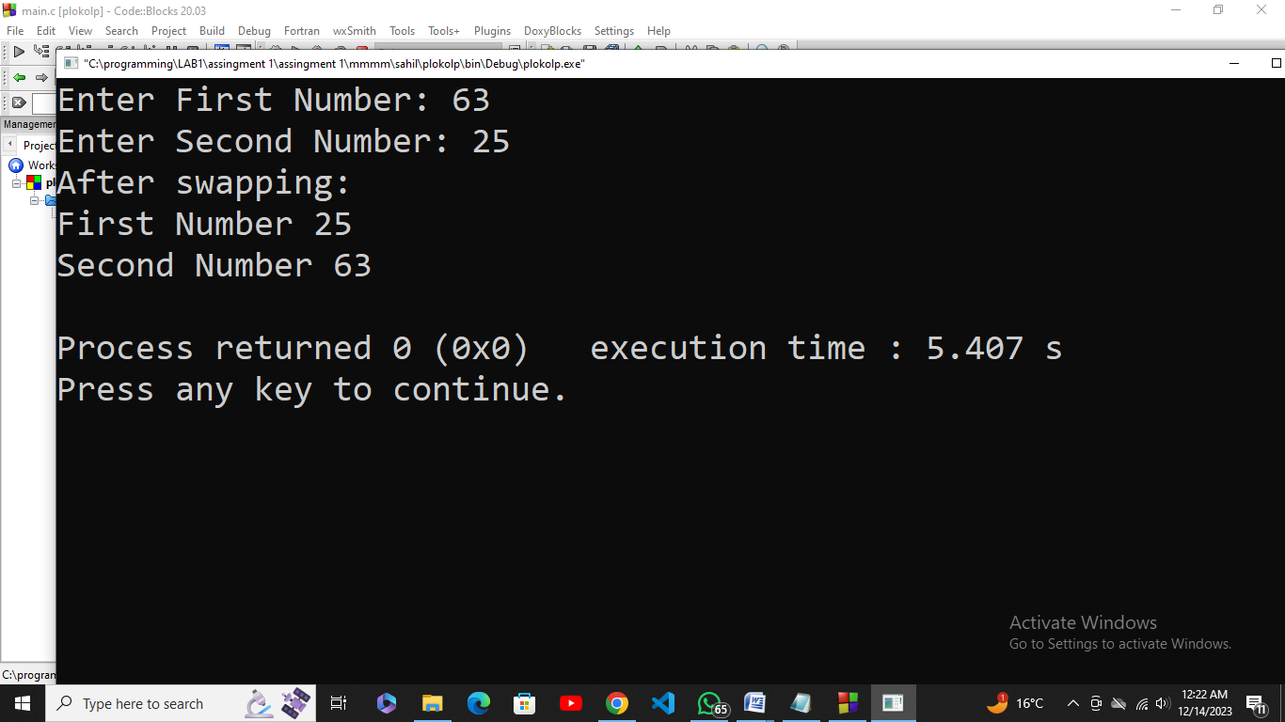

a = a + b;

b = a - b;

a = a - b;

printf("After swapping: \n");

printf("First Number %d\n", a);

printf("Second Number %d\n", b);

return 0;

}